Bethlehem Lutheran School

Bethlehem Lutheran School
1121 Georgia Ave
Sheboygan WI 53081
Phone: 920-452-5071
Fax: 920-452-0209
www.ourbethlehem.com

Our Programs:
3 Year old Kindergarten – Monday, Tuesday and Thursday 8:05am to 11:15am

4 Year old Kindergarten – Monday, Tuesday, Wednesday and Thursday 8:05am to 11:15am

5 Year old Kindergarten – Monday, Tuesday, Wednesday, Thursday Friday 8:05am to 3:05pm
-There is an optional half day program that goes until 11:30am. For more information please talk with the teacher.

Extended Care
7:00 – 8:00 AM 3K Classroom
8:00 – 11:15 am 3 year olds Wed & Fri
4 year olds Fridays
11:15 – 3:00 pm 3 & 4 year olds
3:00 – 5:45 pm All grades
Early arrivals may be pre-arranged.
Lunch time is at 11:30 am. Students wanting to take hot lunch or milk need to have funds in their lunch/milk account. The Federal Free and Reduced Lunch Program is available for those who qualify.
Nap/rest time occurs each day in the afternoon after lunch/recess.
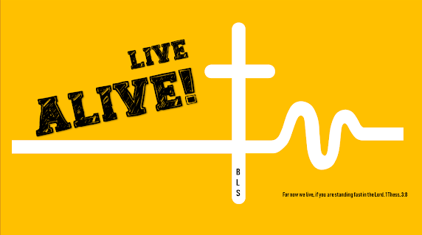
Early Childhood Programs 3K,4K & 5K
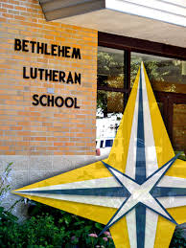
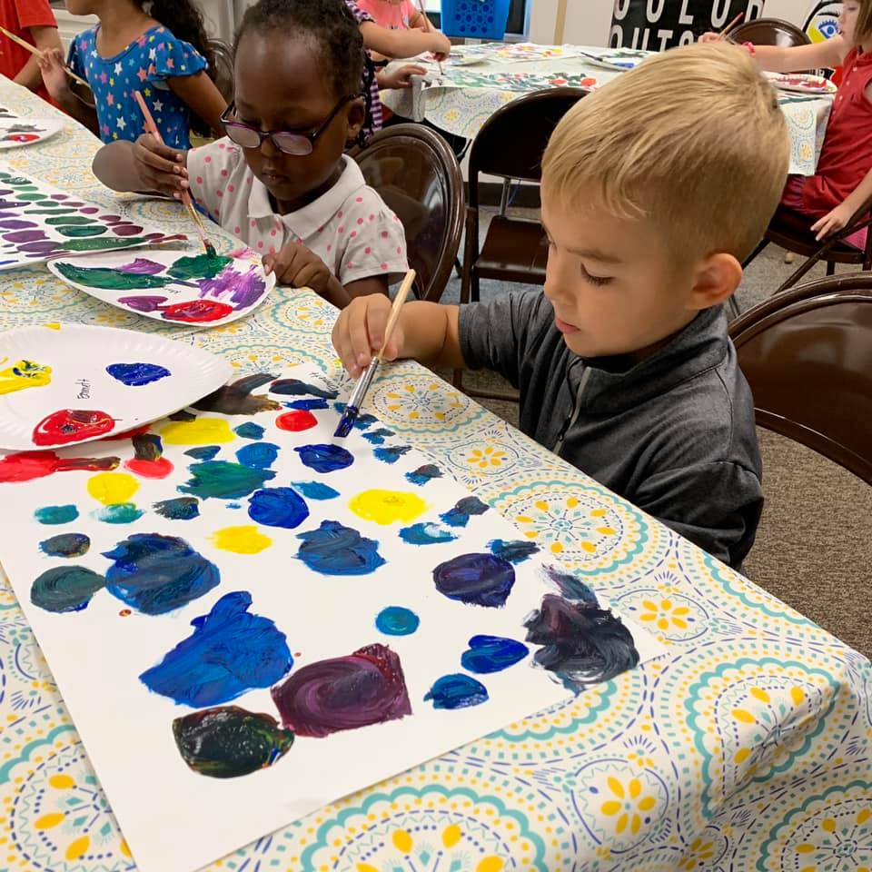

Bethlehem is a participant in the WPCP (Wisconsin Parental Choice Program) for 4K to grade 8. This provides vouchers to cover the cost of the student’s tuition. Enrollment in this program is February 1st to April 20th.
Bethlehem participates in the National Free and Reduced Lunch Program for grades 4K to grade 8
Financial Assistance is available for all students who qualify. If you have questions, please contact the office.

Quality Christian Education
What will your child learn?
1. Religion: to develop the knowledge that Jesus is the child's personal Savior and that God is the Creator and Giver of everything; to promote living as a child of God; to promote the child's awareness of Bible stories, hymns, songs, and Bible passages.
2. Reading/Language Development: to provide experiences with books and the printed word through story time and individual exposure; to promote experience in receptive and expressive use of language and language patterns; to develop auditory perception skills; to provide experiences with the organization of print and discrimination between units of the written word; to develop a positive attitude toward reading, speaking, and the printed word; to correctly identify all capital and lower case letters of the alphabet at random; and to identify initial consonant sounds.
3. Mathematics: to provide experiences with the concepts of classification, comparison, patterns, and numbers through concrete application and examples.
4. Socialization Skills: to promote children working together productively in group settings and an organization context.
5. Science/Social Studies: to promote the child's awareness of the physical environment in terms of their bodies, plants, animals, and the weather and seasons, as well as his/her geographical/cultural environment in terms of the neighborhood and community.
6. Aesthetics (Music, Art): to promote the child's awareness of cultural and aesthetic value of the fine arts areas.
7. Physical Education: to provide for development of fine and gross motor skills; to promote good lifetime health habits.
8. Personal Learning Skills: to develop skills in attending to tasks, completing tasks independently, and following simple directions successfully.

Fun Activities/Projects

Age of Eligibility
By September 1, a child must be three years old to enter 3K, four years old to enter (4K) Kindergarten, five years old to enter (5K) kindergarten, and six years old to enter first grade. A birth or baptismal certificate must be presented as evidence of birth date. Students should be potty-trained before starting classes
Bethlehem Lutheran School admits students of any race, color, national/ethnic origin to all the rights, privileges, programs, and activities generally accorded or made available to students of the school. It does not discriminate on the basis of race, color, national/ethnic origin in administration of its educational policies, admissions policies, athletics, and other school administered programs.

