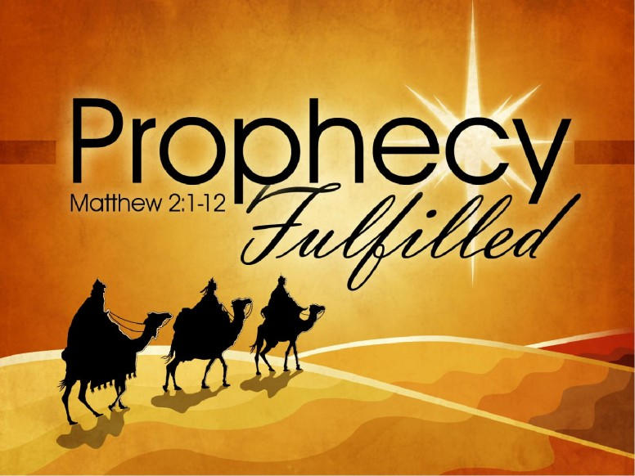

Grades 4, 5 & 6

Advent Service 2024 –

Prophecies Fulfilled

**Pastoral Welcome to Worship**

**Opening Hymn:** ***What Hope! An Eden Prophesied,*** **LSB 342**

1 What hope! An Eden prophesied

    Where tame live with the wild;

The lamb and lion side by side,

     Led by a little child!

2 A shoot will sprout from Jesse’s stem,

    A branch from David’s line,

A Prince of Peace in Bethlehem:

     The fruit of God’s design.

3 As banner of God’s love unfurled,

     Christ came to suffer loss,

That by His death a dying world

    Would rally to the cross.

4 Come, Jesus, come, Messiah Lord,

    Lost Paradise restore;

Lead past the angel’s flaming sword—

     Come, open heaven’s door.

Text: Stephen P. Starke, 1955

Text: © 1998 Stephen P. Starke, admin. Concordia Publishing House. Used by permission: LSB Hymn License no. 110005811

**Prayer to begin worship:**

*Heavenly Father,*

*The Bible is not just a bunch of stories. It is the truth. Help us to embrace the historical significance of Scripture, and strengthen our trust in you to explain the parts we don’t understand, in your perfect timing. Advent should create in us a hope rooted in Jesus Christ, as we discover who he is in the Bible. As we connect the Old and New Testaments of Scripture, knowing we can trust your Word as absolute truth, let Jesus come alive in us like never before. In Jesus’ Name,*

***C: Amen.***

**X X X X X**

**Grades 4, 5 & 6: Prophecy Presentation**

**Offering**

**Hymn:** ***Once He Came in Blessing*, LSB 333**

1 Once He came in blessing,

All our sins redressing;

     Came in likeness lowly,

    Son of God most holy;

Bore the cross to save us;

Hope and freedom gave us.

2 Now He gently leads us;

With Himself He feeds us

    Precious food from heaven,

    Pledge of peace here given,

Manna that will nourish

Souls that they may flourish.

3 Soon will come that hour

When with mighty power

    Christ will come in splendor

    And will judgment render,

With the faithful sharing

Joy beyond comparing.

4 Come, then, O Lord Jesus,

From our sins release us.

    Keep our hearts believing,

     That we, grace receiving,

Ever may confess You

Till in heav’n we bless You.

Text: Johann Horn, c. 1490–1547; (sts. 1, 4): tr. Catherine Winkworth, 1827–78, alt.; (sts. 2–3): tr. Lutheran Service Book, 2006

Text (sts. 1, 4): Public domain

Text (sts. 2–3): © 2006 Concordia Publishing House. Used by permission: LSB Hymn License no. 110005811

**Grades 4, 5 & 6: The Prophecy Continues**

**Apostles’ Creed**

***C: I believe in God, the Father Almighty, Maker of heaven and earth.***

***And in Jesus Christ, His only Son, our Lord, who was conceived by the Holy Spirit, born of the virgin Mary, suffered under Pontius Pilate, was crucified, died and was buried. He descended into hell. On the third day He rose again from the dead. He ascended into heaven and sits at the right hand of God the Father Almighty. From thence He will come to judge the living and the dead.***

***I believe in the Holy Spirit, the holy Christian Church, the communion of saints, the forgiveness of sins, the resurrection of the body, and the life everlasting. Amen.***

**Prayers**

Father, Every part of Christ’s birth story reflects a prophecy fulfilled. The faithfulness of Joseph and Mary is inspiring, and we pray to be obedient as they were. Life didn’t stop for them because You chose them for this important mission. They still had to go to Bethlehem for the census decreed by Caesar. But God, your purposes were greater, then and now. Help us to remember, when life is unfair and hard, you are still at work in our lives. And nothing can stop the work You have started. In Jesus’ Name,

***C: Amen.***

***The Lord’s Prayer***

***C: Our Father who art in heaven, hallowed be Thy name, Thy kingdom come, Thy will be done on earth as it is in heaven. Give us this day our daily bread; and forgive us our trespasses as we forgive those who trespass against us; and lead us not into temptation, but deliver us from evil. For Thine is the kingdom and the power and the glory forever and ever. Amen.***

***Advent Benediction***

Receive the benediction. In your Advent preparations, remain watchful with your eyes on Christ, whose birth in a manger is a promise of his coming again in glory. And may the blessing of God, Father, X Son and Holy Spirit be with you now and forever.

***C: Amen***

**Closing Hymn:** ***O Jesus So Sweet, O Jesus So Mild,*** **LSB 546**

1 O Jesus so sweet, O Jesus so mild!

For sinners You became a child.

    You came from heaven down to earth

    In human flesh through human birth.

O Jesus so sweet, O Jesus so mild!

2 O Jesus so sweet, O Jesus so mild!

With God we now are reconciled.

    You have for all the ransom paid,

     Your Father’s righteous anger stayed.

O Jesus so sweet, O Jesus so mild!

3 O Jesus so sweet, O Jesus so mild!

Joy fills the world which sin defiled.

    Whate’er we have belongs to You;

     O keep us faithful, strong, and true.

O Jesus so sweet, O Jesus so mild!

Text: Valentin Thilo, 1607–62, abr.; (st. 1): tr. Geoffrey W. Daisley, 1877–1939, alt.; (sts. 2–3): tr. Frieda Pietsch, 1904–82, alt.

Text: Public domain